24SDCS02 / 24SDCS02E / 24SDCS02P / 24SDCS02L – FSAD WORKBOOK
DEPARTMENT OF CSE, CS&IT, AI&DS
COURSE CODE: 24SDCS02 / 24SDCS02E / 24SDCS02P / 24SDCS02L
FULL STACK APPLICATION DEVELOPMENT
Date of the Session: / Time of The Session:

#SKILL - 4 ⎝ Spring Dependency Injection – Constructor & Setter Injection

A training institute wants to automate the management of student information in a Spring application. The system should inject details such as studentId, name, course, and academic year into objects without manually assigning values. This Skill demonstrates Constructor Injection and Setter Injection using both XML and Annotation configurations.
Tasks:
1. Create a Java class named Student with fields: studentId, name, course, year.
2. Create a Constructor that accepts all fields and assigns values.
3. Create Setter methods for at least two fields (example: course, year).
4. Configure the Student bean using: a. XML Configuration - The student should take:
• a POJO class
• an XML configuration file
• a main class to load the container b. Annotation Configuration - The student should take:
• a POJO class
• a Java class with necessary annotations
• a main class to load the container
5. Create a Spring configuration file (XML or Java-based).
6. Write a main class to load the Spring IoC container.
7. Retrieve the Student bean and print the injected values.
8. Push the Spring (core) project to GitHub. T E A M FSAD P a

codes

- MainApp.java
package com.klu.main;

import org.springframework.context.ApplicationContext;
import org.springframework.context.support.ClassPathXmlApplicationContext;

import com.klu.model.Student;

public class MainApp {
public static void main(String[] args) {

ApplicationContext ctx =
new ClassPathXmlApplicationContext("applicationContext.xml");

Student st = (Student) ctx.getBean("student");
st.display();
}
}

- StudentXmlDiApplication
package com.klu;

import org.springframework.boot.SpringApplication;
import org.springframework.boot.autoconfigure.SpringBootApplication;

@SpringBootApplication
public class StudentXmlDiApplication {

public static void main(String[] args) {
SpringApplication.run(StudentXmlDiApplication.class, args);
}

}
- Student.java
package com.klu.model;

public class Student {

private int studentId;
private String name;
private String course;
private int year;

// Constructor Injection
public Student(int studentId, String name, String course, int year) {
this.studentId = studentId;
this.name = name;
this.course = course;
this.year = year;
}

// Setter Injection
public void setCourse(String course) {
this.course = course;
}

public void setYear(int year) {
this.year = year;
}

public void display() {
System.out.println("Student ID : " + studentId);
System.out.println("Name : " + name);
System.out.println("Course : " + course);
System.out.println("Year : " + year);
}
}
applicationContext.xml
<?xml version="1.0" encoding="UTF-8"?>
<beans xmlns="http://www.springframework.org/schema/beans"
xmlns:xsi="http://www.w3.org/2001/XMLSchema-instance"
xsi:schemaLocation="
http://www.springframework.org/schema/beans
http://www.springframework.org/schema/beans/spring-beans.xsd">

<bean id="student" class="com.klu.model.Student">
<!-- Constructor Injection -->
<constructor-arg value="101"/>
<constructor-arg value="Akshaya"/>
<constructor-arg value="Java Full Stack"/>
<constructor-arg value="2"/>

<!-- Setter Injection -->
<property name="course" value="Spring Framework"/>
<property name="year" value="3"/>
</bean>

</beans>

Project structure
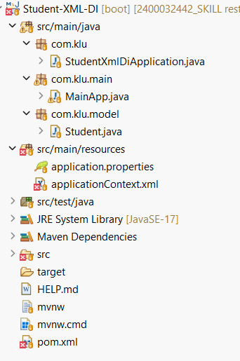

Output:
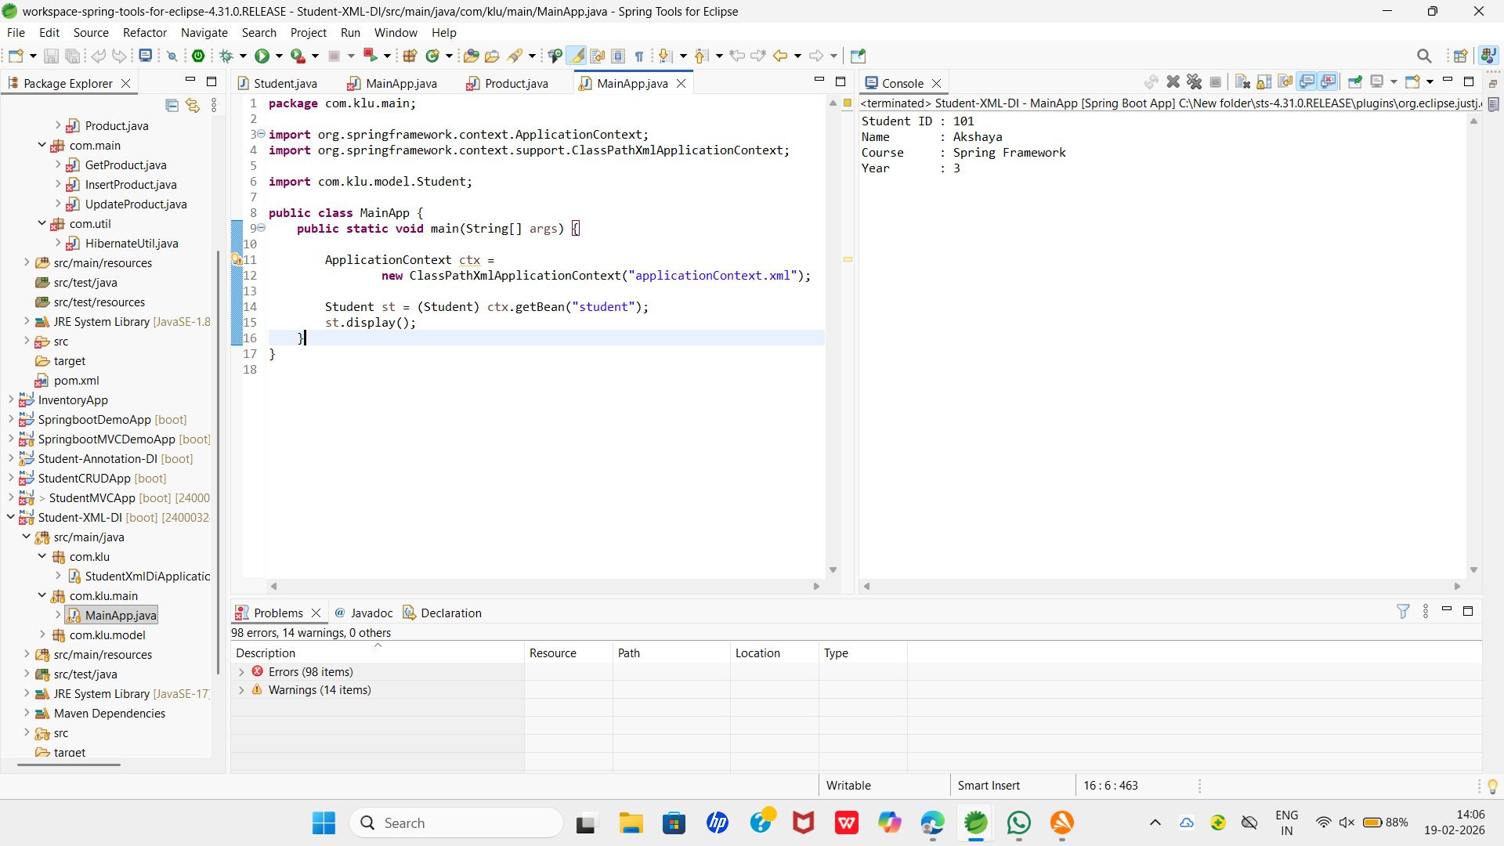


GITHUB:
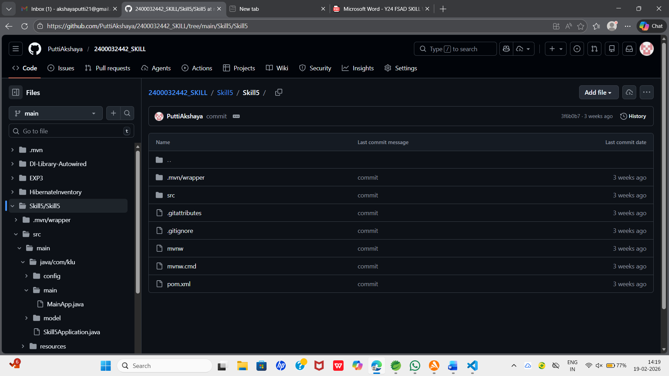

VIVA QUESTIONS:
1. What is Dependency Injection (DI) in Spring?
A.Dependency Injection (DI) is a design pattern used in the Spring Framework where objects receive their dependencies from the Spring container instead of creating them themselves.
Instead of:
StudentService service = new StudentService();
Spring injects the dependency automatically.
DI promotes:
- Loose coupling
- Better testability
- Easier maintenance

2. What is the difference between Constructor DI and Setter DI?
Constructor Injection | Setter Injection
Dependencies are injected through the constructor | Dependencies are injected using setter methods
Used for mandatory dependencies | Used for optional dependencies
Ensures object is fully initialized | Object can be partially initialized
Preferred in modern Spring | Used when dependency may change later
Example:
Constructor DI
@Autowired
public StudentController(StudentService service) {
this.service = service;
}
Setter DI
@Autowired
public void setStudentService(StudentService service) {
this.service = service;
}

3. What is the purpose of the IoC container?
The Inversion of Control (IoC) container in Spring:
- Creates objects (beans)
- Manages their lifecycle
- Injects dependencies
- Handles configuration
Examples of IoC containers:
- BeanFactory
- ApplicationContext
It shifts control of object creation from the programmer to the Spring framework.

4. Why is DI preferred over manual object creation?
DI is preferred because it:
- Reduces tight coupling
- Makes unit testing easier (mocking possible)
- Improves flexibility
- Makes code more maintainable
- Follows SOLID principles
Manual object creation creates tightly coupled code.

5. Can Constructor Injection and Setter Injection be used together?
Yes, both can be used together in the same class.
Common practice:
- Use Constructor Injection for mandatory dependencies.
- Use Setter Injection for optional dependencies.
This combination gives flexibility and ensures required dependencies are always available.

Comment of the Evaluator (if Any)

Evaluator’s Observation
Marks Secured: out of
EMP ID & Full Name of the Evaluator:

Signature of the Evaluator Date of Evaluation:

